第590次SKLBE学术论坛
报告人：Federal Center of Brain Research and Neurotechnologies, Vsevolod V. Belousov教授
报告题目：Synthetic biology tools to control cell signaling, metabolism, and function
报告时间：2023-9-20(周三) 15:00 -16:00
报告地点：实验18楼315室
主持人：杨弋教授

报告人简介：
Vsevolod V. Belousov  born 19.02.1975, USSR  position: CEO of the Federal Center of Brain Research and Neurotechnologies, Moscow, Russia  e-mail belousov@fccps.ru,  phone 7 915 2045200 | 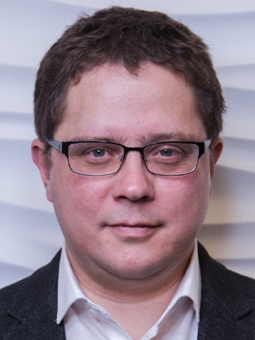
EDUCATION/TRAINING
INSTITUTION AND LOCATION | DEGREE  (if applicable) | Completion Date  MM/YYYY | FIELD OF STUDY
Shemyakin-Ovchinnikov Institute of Bioorganic Chemistry | Habilitation, D.Sc | 02/2013 | Molecular biology
Moscow State University, Moscow, Russia | Ph.D. | 06/2002 | Biochemistry
Moscow State University, Moscow, Russia | M.S. | 05/1998 | Biochemistry

A. Personal Statement

In my research I apply synthetic biology principles to study redox signaling, to develop molecular tools for in vivo imaging, metabolic engineering and optogenetics. In addition, I study molecular mechanisms of ischemic pathology, signaling in cancer cells, an interplay between calcium and reactive oxygen species and other relevant topics. The central principle of my research is trans-species and even trans-kingdom transfer of molecular blocks in order to obtain engineered living system with new properties. My achievements in the field of redox biology and fluorescent microscopy include development of sensors for important redox active compounds within living cells, novel tools for thermogenetics, new methods of super resolution microscopy, etc. My scientific results were published in high-impact journals including Nature, Nature Methods, Nature Chemical Biology, Nature Communications, NANO Letters, ACS Chemical Biology, Cell Metabolism, EMBO Journal and others. In my lab I supervised 5 completed PhD projects (plus 6 ongoing) and more than 20 master and bachelor theses.

B. Positions and Honors

Positions and Employment
2019-present CEO of the Federal Center of Brain Research and Neurotechnologies, Moscow, Russia
2018-present Head of Department of metabolism and redox biology, Shemyakin-Ovchinnikov Institute of Bioorganic Chemistry, Moscow, Russia
2017-2022 Guest Professor, Mercator Fellow, University Medical Center Göttingen, Georg-August University, Germany
2016-present Professor of Russian Academy of Sciences
2016-present Head of Molecular technologies laboratory, Shemyakin-Ovchinnikov Institute of Bioorganic Chemistry
2013-2016 Head of Redox biology group, IBCH
2014-2016 Visiting scientist, Saarland university, Germany
2006-present Visiting scientist, EMBL Heidelberg
2011-2013 Visiting scientist, Cold Spring Harbor Laboratory, USA
2004-2013 Research scientist, senior scientist, IBCH
2002-2004 Research Scientist, Evrogen JSC, Moscow
1998-2002 PhD student, Moscow State University

Other Experience

- Project reviewer for Wellcome Trust, European Research Council, Netherlands Organization for Scientific Research, The French National Research Agency, Bonfor foundation, and all Russian scientific agencies.
- Reviewer for Nat Comm, Nat Meth, Nat Chem Biol, Chemical Science, FEBS journal, EMBO J, Antioxidants & Redox signaling, JBC and many other journals.

- Organizer of EMBO conference on redox biology, Moscow – Saint-Petersburg 2017;

- Invited speaker at >100 international conferences
- Teacher and lecturer at “Advanced light microscopy techniques” practical course, EMBL Heidelberg, 2015, 2016, 2017, 2018, 2019
Teacher at "Redox regulation of metabolic processes" FEBS advanced course, 2016.
Teacher at “3rd advanced course in Optogenetics”, Institut Curie, Paris 2016.
Teacher of a lecture course on modern methods in biology, Moscow State University.

Honors

2019 – Society for Redox Biology and Medicine 2019 Discovery Award;

2005 - The Society for Free Radicals Research - Europe: Young investigator award in recognition of extraordinary scientific achievements in the field of free radicals research.

Publications
https://scholar.google.com/citations?hl=en&user=nY1dJkEAAAAJ

